**IFT 466 Advanced Computer Networks**

**Lab 34  
  
HDLC + PPP**High-level Data Link Control Protocol (Cisco Proprietary) + PPP – Point to Point protocol (PPP)

After you complete each step, put a ‘√’ or ‘x’ in the completed box

**Objectives**

Set up WAN connection with 2 routers and check what is the current/default encapsulation in the routers.

Configure the routers with WAN protocols HDLC and PPP and verify successful connection between the routers.

**Background**

Information received from LAN need to be converted to a different format to be sent across a WAN network.

This method is called encapsulation where information is converted from one format to another. This conversion is done by protocols.

2 WAN protocols used on serial links to send data over WAN interfaces are1) HDLC – High-level Data Link Control Protocol (Cisco Proprietary) and PPP – Point to Point protocol (PPP) (Standard Protocol)

**Part A: Set up WAN connection with 2 routers and check the default encapsulation**

1. Create the following network topology on Packet Tracer.

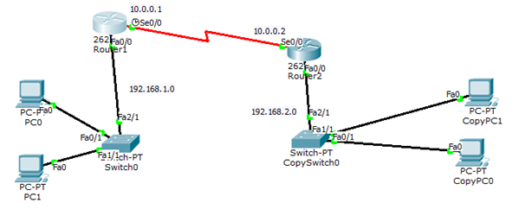



✓

1. Make sure that every node on the network can communicate with every other node (RIP, OSPF, or static routes are all okay).

 ✓

1. Use the show interfaces s0/0 command on Router 1 to check what is the default encapsulation on router interface which connects to WAN

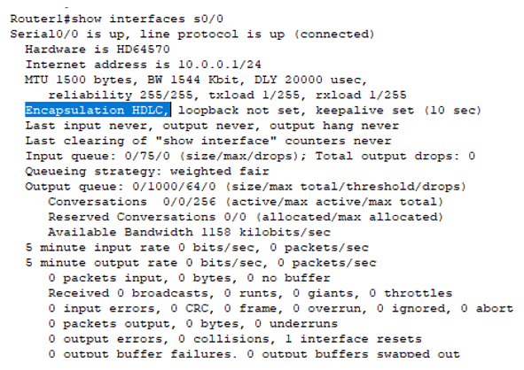

 ✓

1. Repeat the show interfaces command (as you performed in step 3) on Router 2. It should also show the default encapsulation as HDLC

 ✓

1. Ping from Router 2 to serial interface in router 1 which is connected to WAN.

Was it successful?

 ✓

It should be successful since both the routers have the same WAN protocol i.e. HDLC

**Part B: Configure and verify PPP**

1. Configuration of PPP  
     
   Lets configure PPP to serial interface 0/0 in Router 1 using below commands:

Router1(config)#int serial 0/0

Router1(config-if)#encapsulation ppp



✓

1. Now verify if the encapsulation changed using command: show interfaces serial 0/0.   
     
   Encapsulation should now show as PPP

 ✓

1. Now verify if the protocol for the interface is up using the show ip int brief command

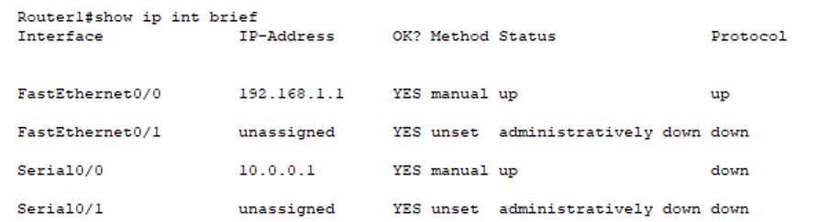

Status of the interface shows up, however the protocol shows down.



✓

1. Why is protocol down for Router 1 with interface up even after configuring ppp?  
     
   There is an encapsulation mismatch.   
     
   While we changed protocol for Router 1 to PPP, protocol for Router 2 is still HDLC.   
     
   So, format sent by PPP protocol will not be understood by HDLC protocol. Hence, interface will be up but protocol will be down.

 ✓

1. Ping serial interface in router 1 from Router 2.   
     
   Was it successful?

 Should be a “No”

✓

1. How can we fix this issue?

We must change the encapsulation to PPP in Router 2 interface or change the encapsulation back to HDLC on Router 1)

****For this lab we will change the protocol in Router 2)

✓

1. ****Go into Router 2 and follow the same commands to change encapsulation to PPP as we did on Router 1.   
     
    ✓
2. Now check the interfaces using show interfaces brief command on both Router 1 and Router 2 to verify if protocol is up.   
     
   The protocol will now be ‘up’ on the WAN interface for both Router 1 and Router 2?

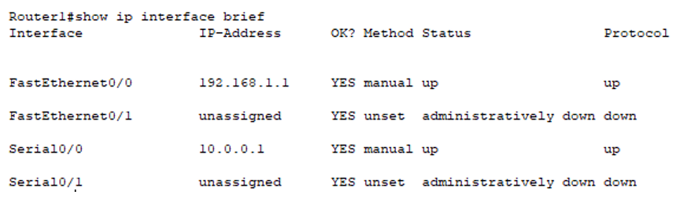

 ✓

1. Now try ping between Router 1 and Router 2 again. Ping from Router 2 to serial interface in router 1 which is connected to WAN. Was it successful? Should now be a ‘Yes’

 ✓

**Part C: Configure and verify PPP**

1. We can follow the same commands to change protocol to HDLC to both Router 1 and Router 2.   
     
   Protocol need to be changed in both routers for protocol to be up.

Router1(config)#int serial 0/0

Router1(config-if)#encapsulation hdlc

 ✓

1. Verify protocol changed in both routers by using the command : show interfaces serial 0/0



✓